Practical 1:-

SITEMAP:-
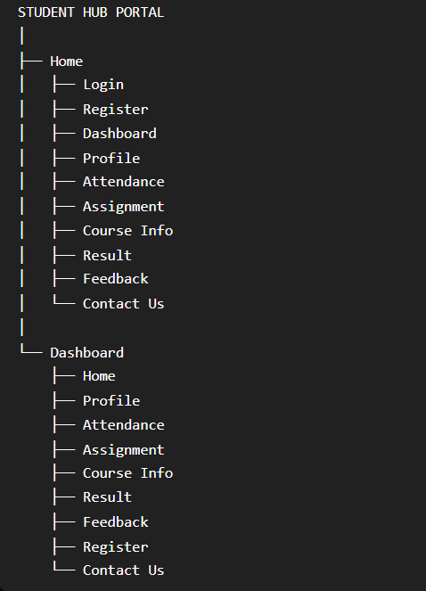

WIREFRAME:-
Page1:-
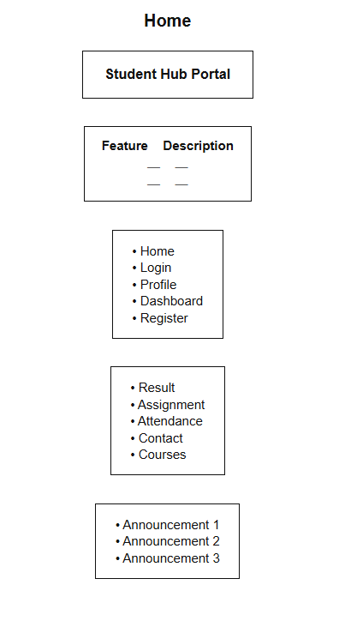
HOME PAGE
Purpose:- Landing page that introduces the portal, links to every other page, and shows announcements plus a summary of what each feature does.

Page 2:-
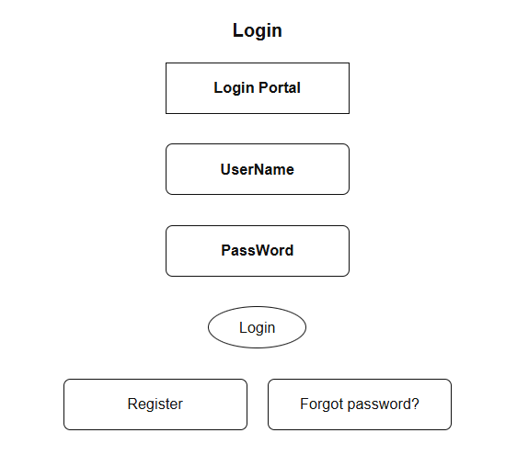

Login page

Purpose:- Lets a student sign in with their student ID and password to access the portal.

Page 3:-
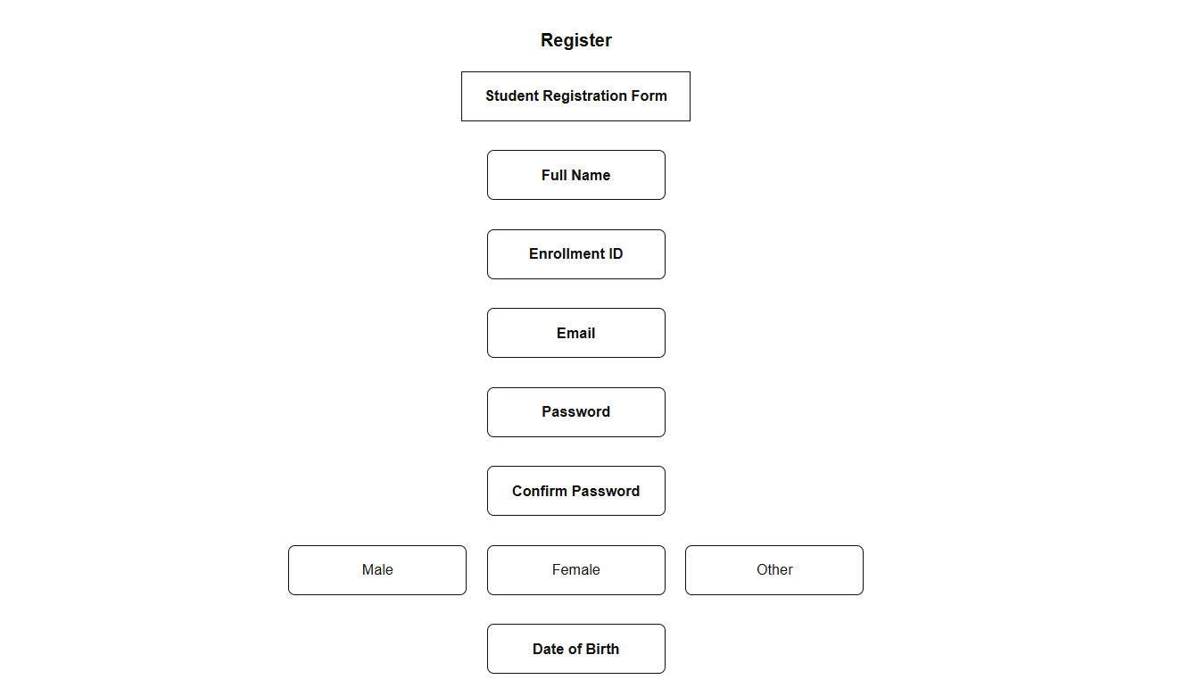
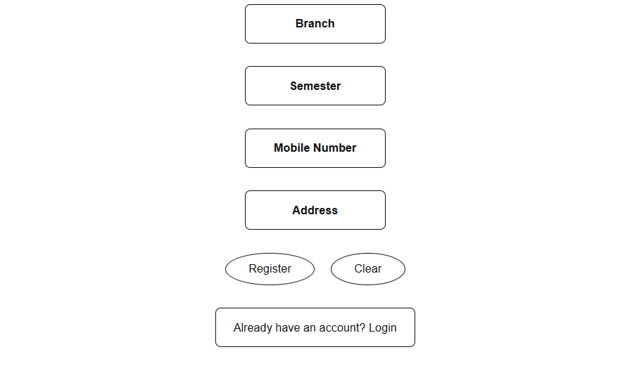
Register page
Purpose:- Lets a new student create an account by entering personal, academic, and login details.

Page 4:-
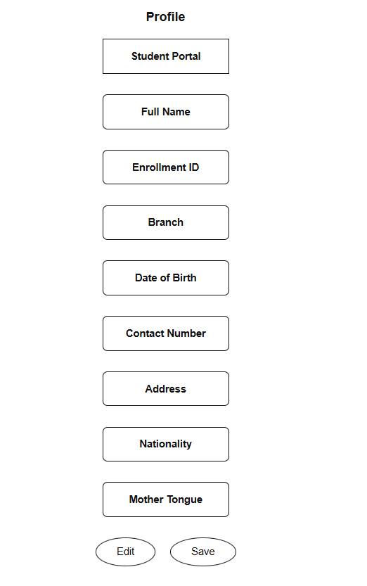

Profile page

Purpose:- Shows and lets the student edit their personal details (name, branch, contact info, address, etc.).

Page 5:-
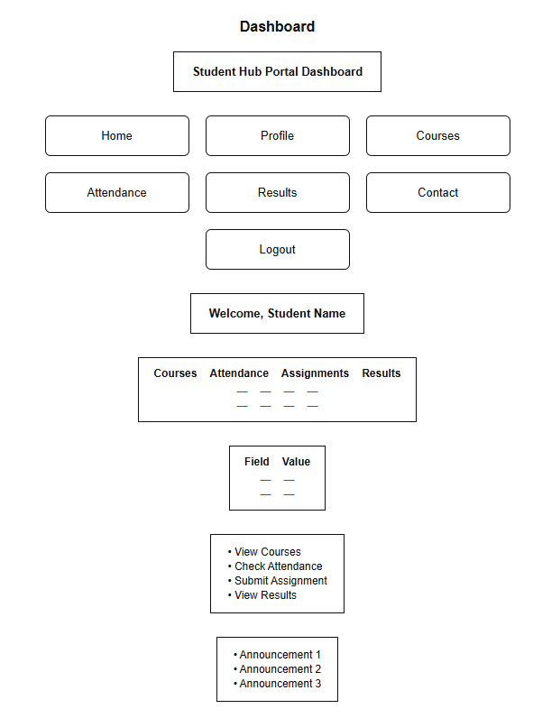

Dashboard page

Purpose:-. The main hub after logging in; gives an at-a-glance summary (courses, attendance %, pending assignments) plus quick links to everything else.

Page 6:-
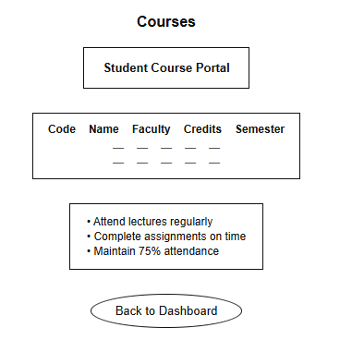
Course page
Purpose:-. Lists the courses the student is enrolled in, along with faculty, credits, and semester.

Page 7:-
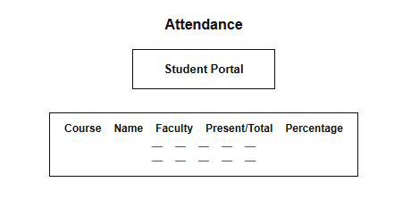
Attendance page
Purpose:- Shows attendance records per course (classes attended vs. total, and percentage).

Page 8:-
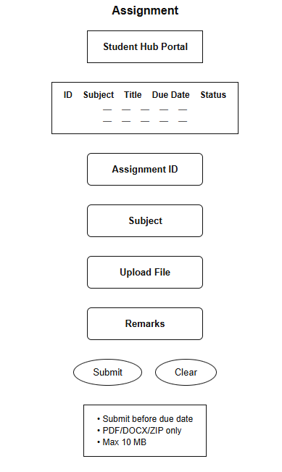
Assignment page

Purpose:- Lists assigned work and its submission status, and provides a form to upload/submit an assignment.
Page 9 :-
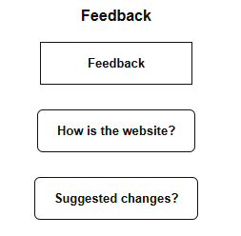
Feedback page
Purpose:- A simple form for the student to leave feedback on the website itself.

Page 10:-
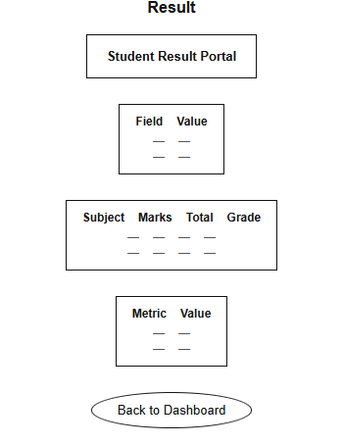
Result page
Purpose:- Displays semester exam results — subject-wise marks, grades, and an overall pass/fail summary.
Page 9 :-
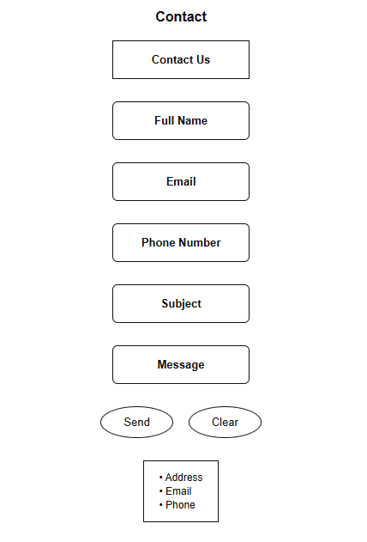
Contact page
Purpose:- Lets the student send a message/query , and shows the college's contact details.

